SPRINT – 1

|  |  |
| --- | --- |
| **Team ID** | **PNT2022TMID29859** |
| **Project Name** | **Skill/Job Recommender Application** |

RUNNING WITH PYTHON FLASK:

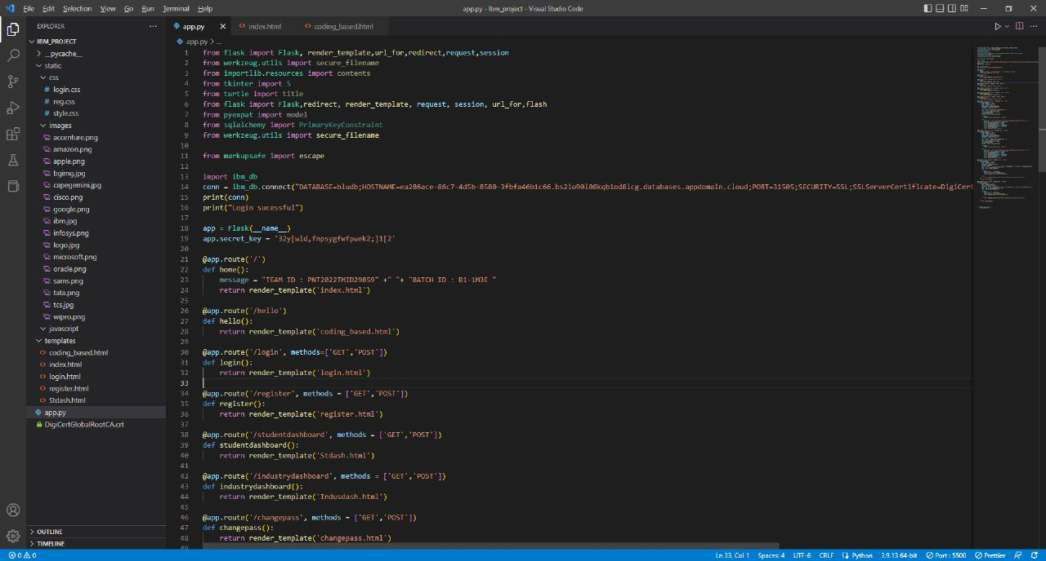

INDEX PAGE:



ABOUT US PAGE:

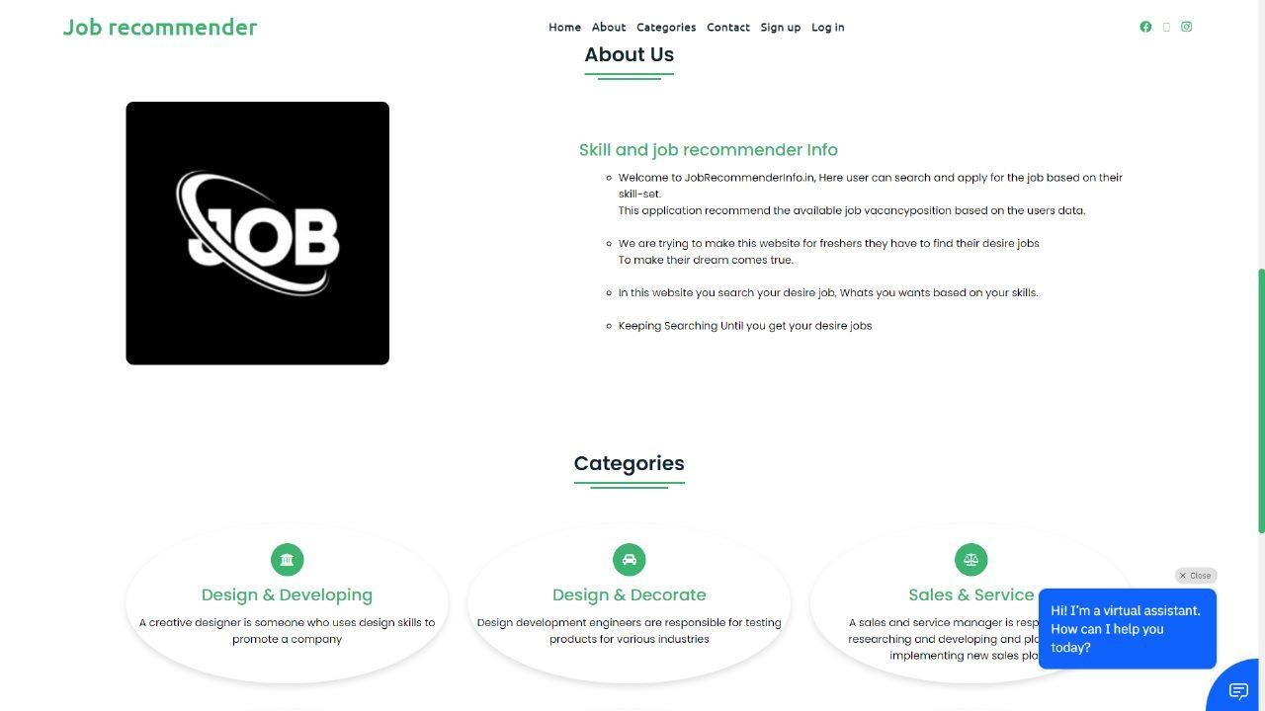

CATEGORIES PAGE:

